Supplementary Plots -The effect of standardising the posterior mean ability parameters.

In the plots displayed below, the left panel is the original posterior mean ability for the functional domain (y-axis) plotted against the posterior standard deviation(x-axis). The right panel displays the resulting standardised posterior means (y-axis) plotted against the posterior standard deviation(x-axis). The colour represents the number of milestones completed. Each functional domain is displayed on a separate plot. The posterior means for those who have only completed a few milestones get shrunk towards the mean, and those that have completed many milestones get spread out. This standardisation ensures that the ability estimates of children with few measurements are not over or underestimated as there is more uncertainty associated with these children’s abilities.

Auditory functional domain

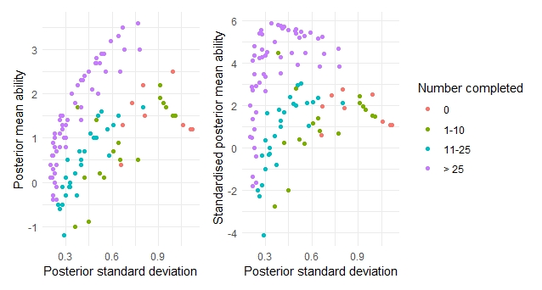

Hands functional domain

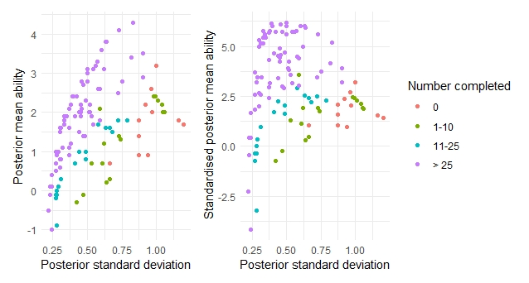

Movement functional domain

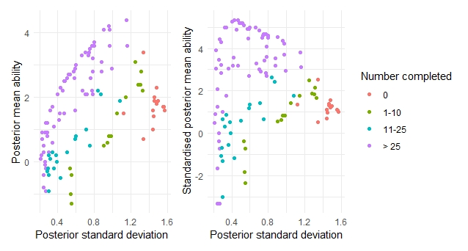

Speech functional domain

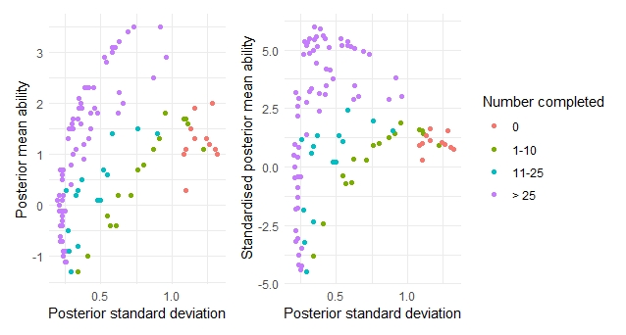

Tactile functional domain

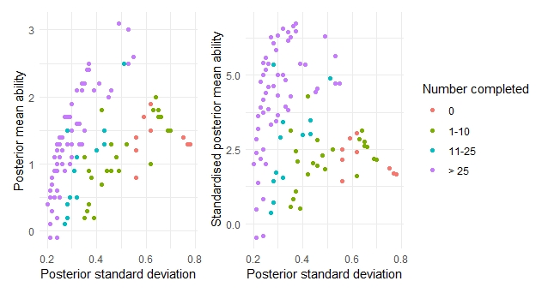

Vision functional domain

